ASSESSMENT - 2
MARKS OBTAINED

_________________
TOTAL MARKS: 50
NAME: _________________________
SUBJECT:
GRADE: UKG
DATE:
TIME: 3 Hours

I.FILL IN THE BLANKS WITH VOWELS : (5x1=5)

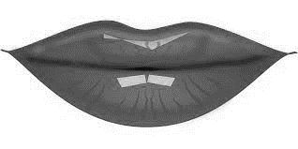
h____t l____p c____t
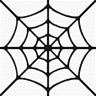
w___b s____n

II.CIRCLE THE RHYMING WORDS : (4x1/2=2)

- jug jog dog

- hot pot fog

III.TICK THE CORRECT ONE : (2x1/2 =1)
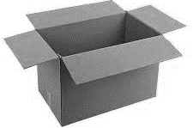

hop
top
fox
box

IV. MATCH THE RHYMING WORDS : (5x1=5)
1. cat log
2. lip hip
3. dog mat
4. Sun wet
5. pet run

V. CIRCLE THE WORDS WITH PHONIC SOUND OF ‘O’ : (4x1/2=2)

pad
hit
fox
cat
man
dog
dip
log
cot
VI. LOOK AT THE PICTURE AND WRITE THE WORD : (3x2=6)
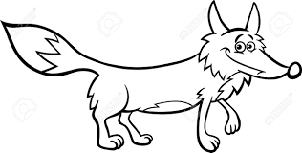

____________ ____________ ___________

VII. WORD BUILDING : (4x1/2=2)

ot

VIII. LOOK AT THE PICTURE AND WRITE YES/NO: (4x1/2=2)
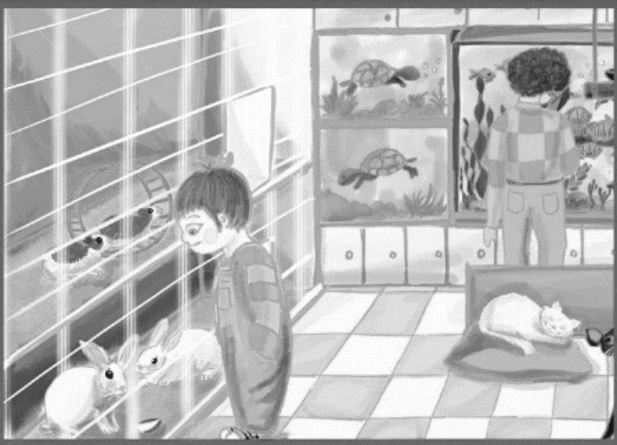
- Ron is in dress shop ?
_________________

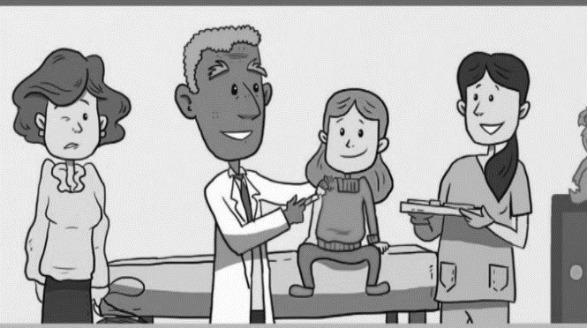

- Did judy cry ? ___________

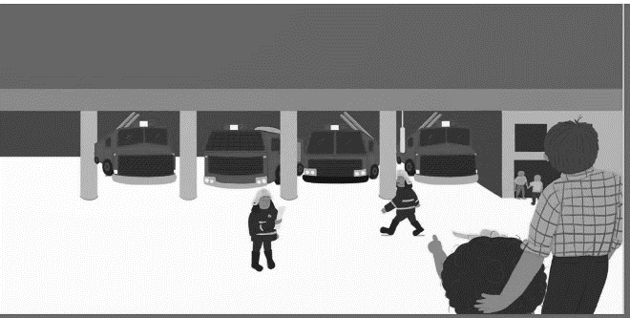

- There are eight fire engines ?
_______________

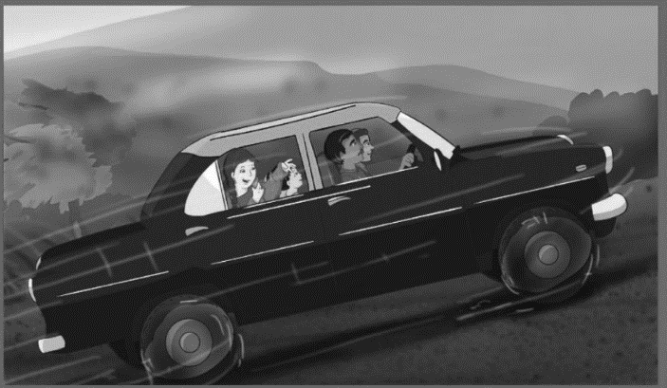

- Mama wears her jacket in the car? ______

IX. FILL IN THE BLANKS WITH THE HELP OF BOX : (5x1=5)
runs | cat | boat | in | sleeps

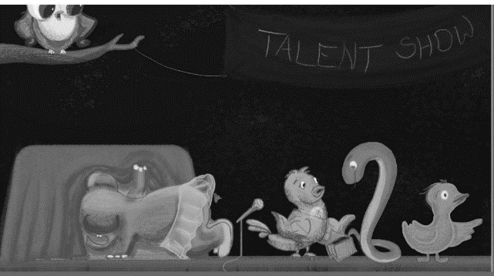
- Are the prizes _______________ cuckoo’s bag?

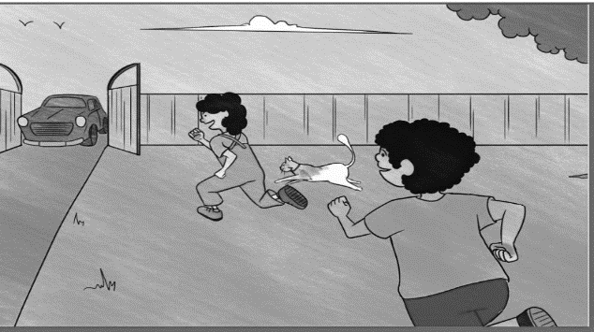

- Pintu ________________ to the gate.

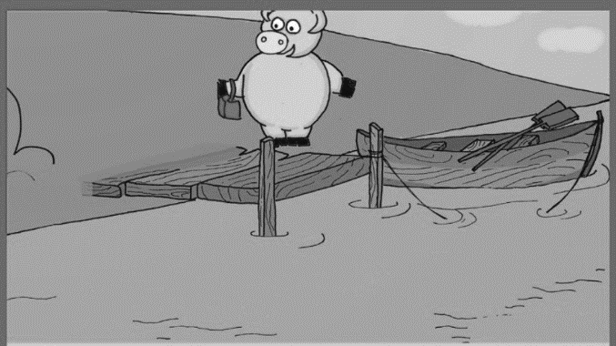

- Here is a small ___________

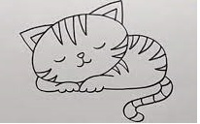

4. The _____________ is sleeping.

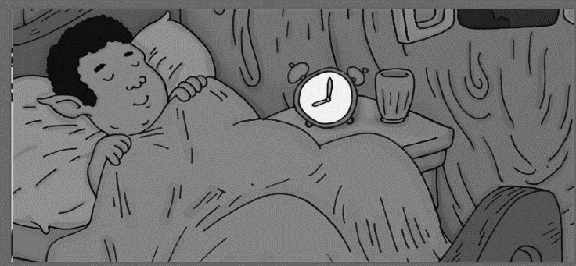

- Laddoo ____________early.

X. ORAL : (20)
1. Rhymes - ( /10 )
2. Reading:
- Sight words - ( /5 )

- Family words - ( /5 )

~~~~~~~~~ ALL THE BEST ~~~~~~~~~

